**PROJECT REPORT**

**SOFTWARE**

**DESIGN TASK**

**HIMANSHU GUPTA**

**The software is designed in Java with extensive use of MySQL and Object-Oriented Programming. The Java application interacts with JDBC API, which uses the JDBC Driver to connect to MySQL Database.**

**The software has been tested using the Junit 5 unit testing framework, which was integrated with Mockito. The classes and methods have been successfully tested, including the testing of void methods. The project is also backed by High-Level and Low-Level design.**

The description of all the tables as well as the task output has been discussed below:

**Database Name: Travel**

**No. of tables: 7**

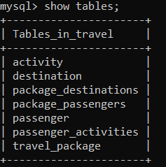

**Description of each table:**

* **Travel Package table**

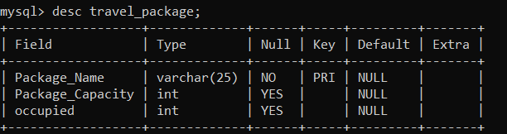

* **Destinations table**

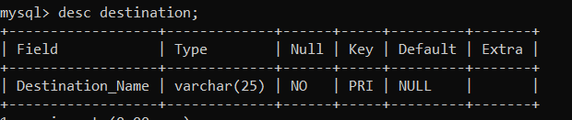

* **Package-Destinations table**

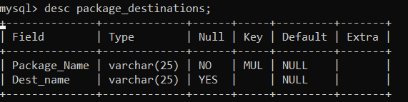

* **Activity table**

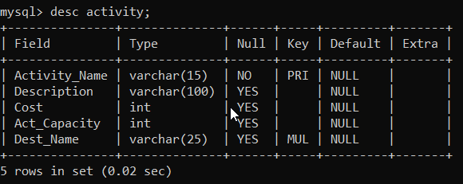

* **Passenger table**

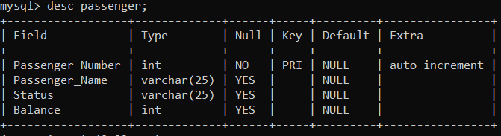

* **Package-Passengers table**

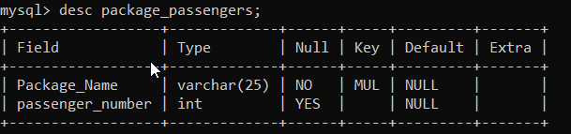

* **Passenger-Activities table**

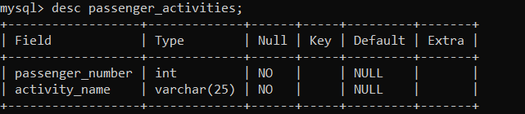

**Dummy Data in each table:**

* **Travel Package table**

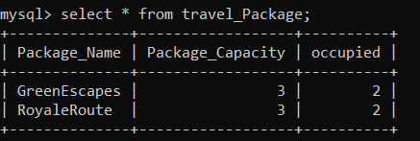

* **Destination table**

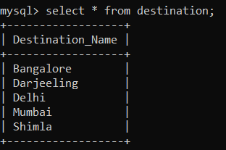

* **Package-Destinations table**

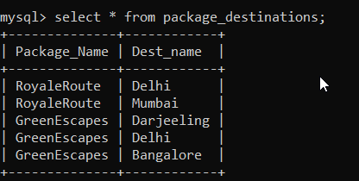

* **Activity table**

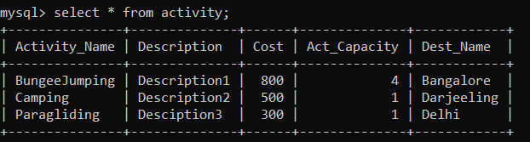

* **Passenger table**

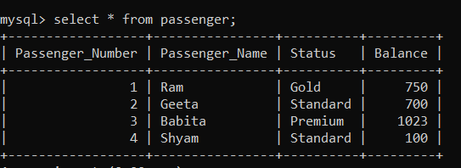

* **Package-Passengers table**

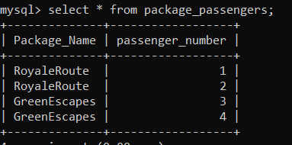

* **Passenger-Activities table**

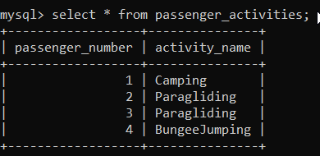

**PROJECT ILLUSTRATION**

**Menu:**

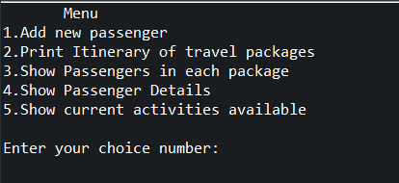

1. **Add New Passenger**

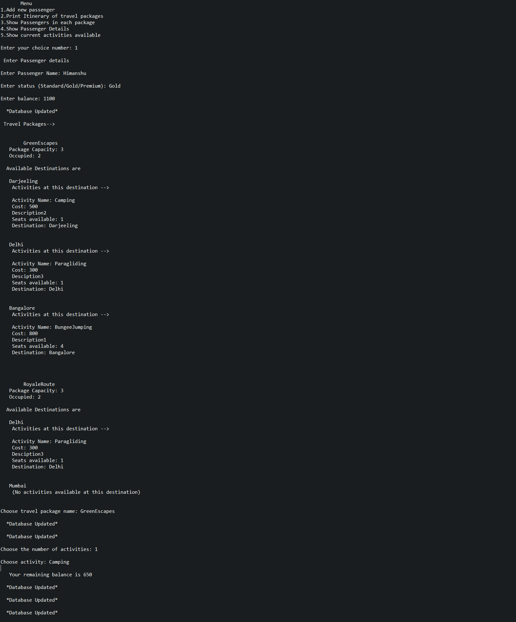

**Changes in database after addition of new passenger:**

* **Passenger table**

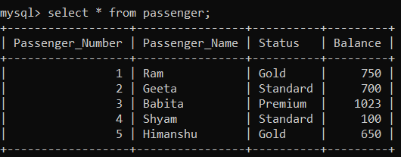

* **Travel Package table**

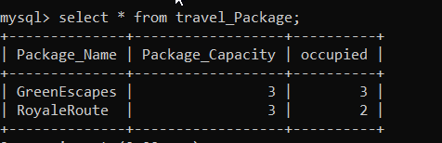

* **Activity table**

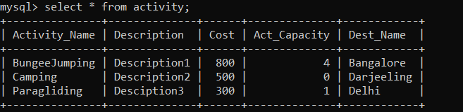

* **Package-Passengers table**

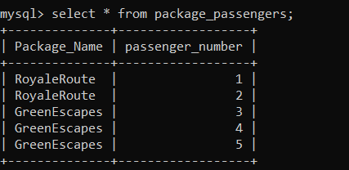

* **Passenger-Activities table**

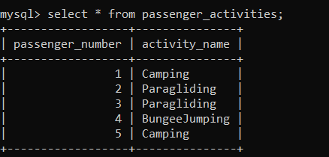

1. **Print Itinerary of travel packages**

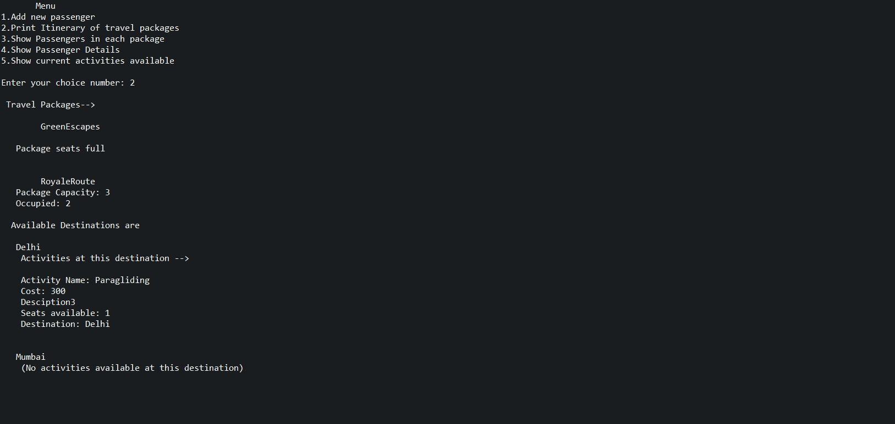

1. **Show passengers in each package**

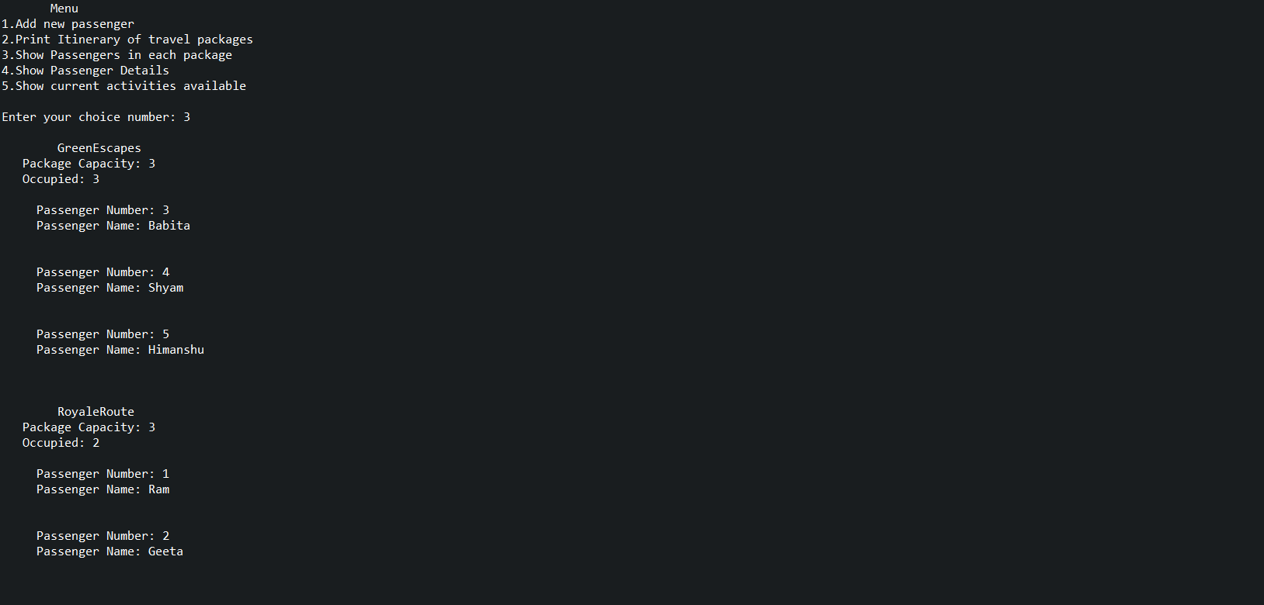

1. **Show passenger details**

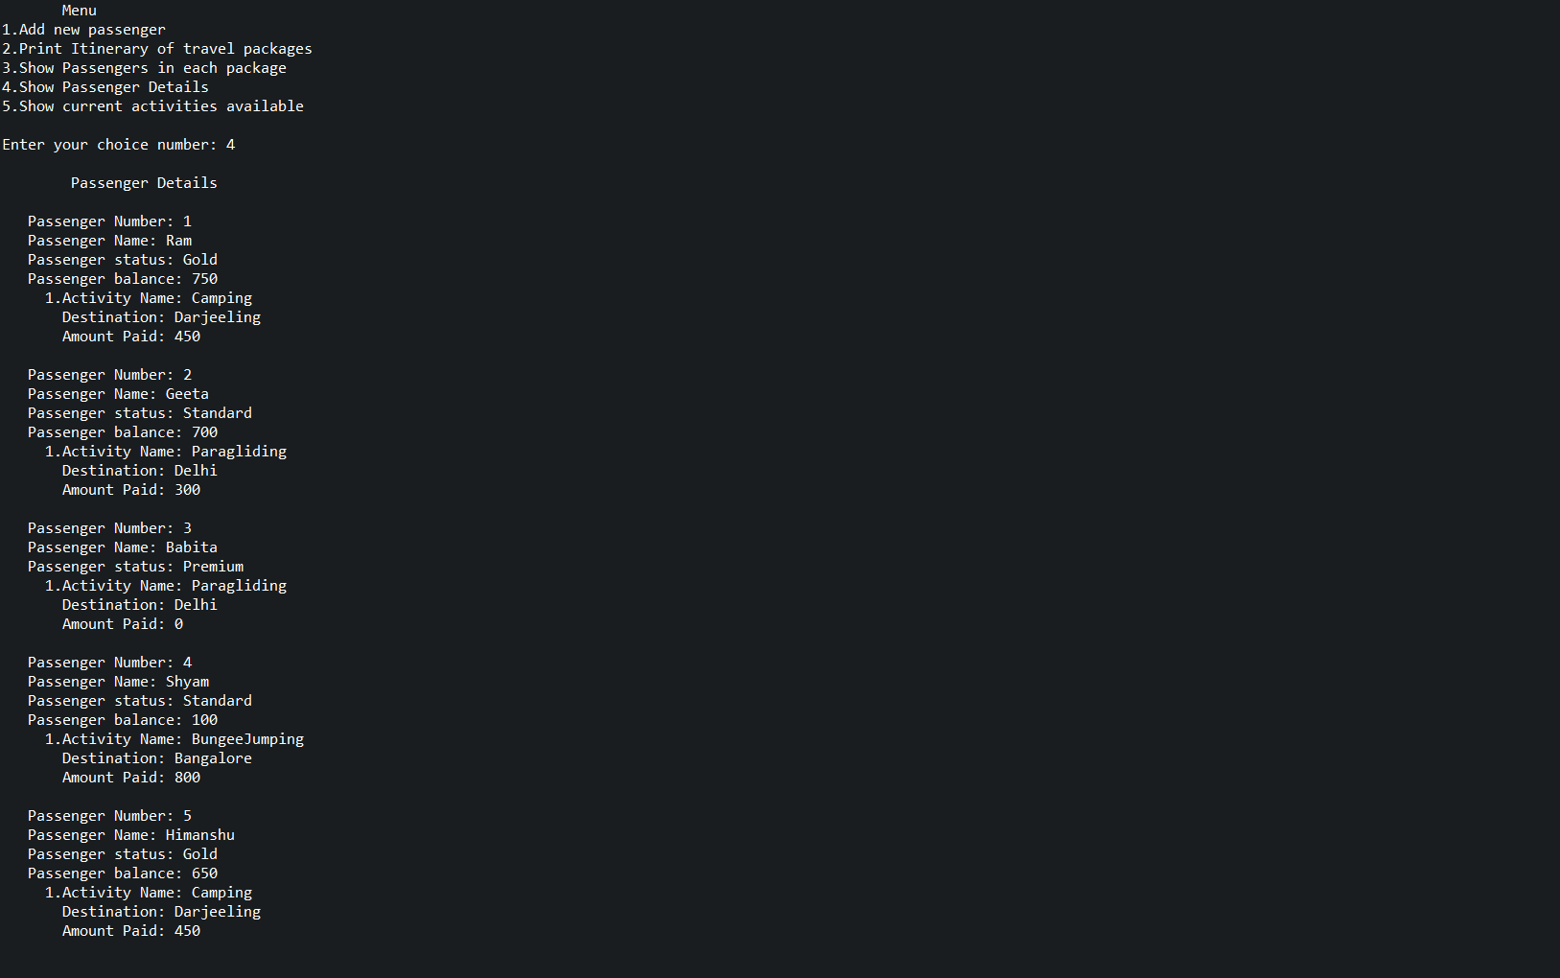

1. **Show current activities available**

